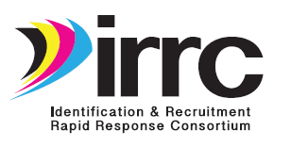
ID&R Consultation Log – Year 1 for the Interim APR (Submit by 9/22/17)
Name_____________________________
 | Date | Consulted with | State or  agency | Topic* | Discussion | Follow-up
1
2
3
4
5
6
7
8
9
10
11
12
13
14
15
16
17
18
19
20
21
22
23
24

Topic Key GOAL 1: 1.1a-Best practices, 1.1b-State ID&R Plans, 1.2a-TRI Teams, 1.2b-TRI TA Protocols, 1.2c-TRI training, 1.2d-TRI deployment, 1.3a- ID&R materials, 1.3b-SMEs; 1.3c-ID&R training. GOAL 2: 2.1a-Design recruiter PD, 2.1b-ID&R skills test, 2.1c-Implement PD, 2.1d-Certify recruiters, 2.2a-Convene SMEs, 2.2b-Pilot new matls, 2.2c-Revise pilot materials, 2.3a-Develop agreements, 2.3b-Consult w/agribusinesses, 2.3c-Five signed agreements. GOAL 3: 3.1a-Design website, 3.1b&c-Website content, 3.2a-ID&R profiles, 3.2b-Newsletter articles, 3.2c-ID&R Action Plans, 3.2d-Lit review, 3.3a-Needs assessment for Resource Roundup, 3.3b-RR formats, 3.3c-RR materials/resources. O=Other (Specify)
Page ___ of ___

